PERSONAL PORTFOLIO:
Emmanuella Mogga
Biomedical Laboratory Science Student
INES Ruhengeri
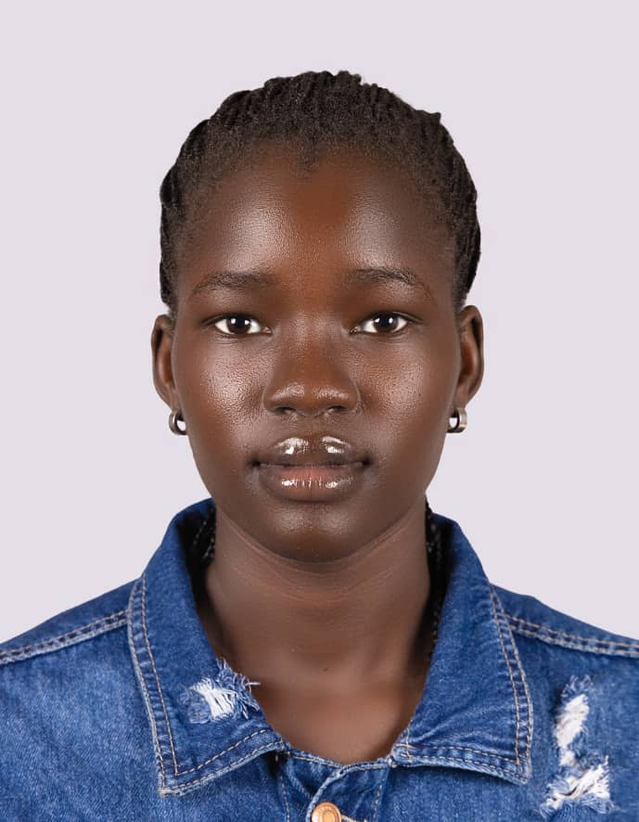

HOME PAGE:
FULL NAME:
Emmanuella Mogga

INTRODUCTION:
I am a dedicated and motivated student pursuing Biomedical Laboratory Science. I am passionate about healthcare and committed to developing the knowledge and skills needed to contribute to patient care and laboratory services.
I am currently studying Biomedical Laboratory Science, with strong interest in laboratory practices, diagnostics, and patient safety.

Personal Goal:
My goal is to become a skilled biomedical laboratory professional who contributes to accurate diagnosis and quality healthcare services.

Favorite Bible Verse:
“The Lord is my shepherd; I shall not want.” – Psalms 23:1

ABOUT ME
Full Name:
Emmanuella Mogga

Educational Background:
I am currently studying Biomedical Laboratory Science at INES Ruhengeri, where I am gaining knowledge and practical skills in laboratory procedures and healthcare services.

Career Interests / Goals:
I am interested in building a career in medical laboratory science, focusing on accurate testing, diagnosis, and supporting patient treatment.

Family Background:
I come from a supportive family that encourages me to work hard and stay focused on my goals.

Church / Faith Involvement:
I am an active member of my church and participate in the choir, which helps me grow spiritually and develop teamwork skills.

Personal Motivation:
I am motivated by my desire to succeed, help others through healthcare, and build a better future for myself and my family.

SKILLS
- Technical Skills:
- Basic computer skills
- Microsoft Word
- Email communication
- File management
- Basic laboratory knowledge

Personal Skills:
- Event planning
- Cooking
- Dancing
- Communication
- Teamwork

PROJECTS
1. Personal Portfolio:
- I created a personal portfolio to showcase my education, skills, and career goals.

2. Academic Activities:
- Participation in laboratory practical sessions.
- Group assignments and presentations.
- Coursework in Biomedical Laboratory Science.

CONTACT:
Email:
emmanuellamogga@gmail.com

Social Media:
+211928912083(WhatsApp)
Phone Number:
0796716456

